Troubleshooting Steps Performed

**WebSphere Config Changes**

1. modified the GC policy for Online Apps from GENCON to OPTTHRUPUT.
   1. This caused a different timeout that causes formset to be submitted without electronic signature. The out of memory error showed up again on the third iteration.
   2. Heap Analyzer shows the heap being taken by char objects.
   3. Garbage Collection (GC) seems like it is not releasing memory even without CSE activity. The GC decreased down to normal after a period of 12 hours.
2. Changed GC policy from OPTTHRUPUT to OPTAVGPAUSE still observed no change in heap usage, reverted the change to GENCON.
3. Modified threadpool for Online App from min 10 to min 0.

Reason to change: We have noticed 3 threads per app are being used even at 0 active sessions and these threads may be holding the char objects.

* 1. Even after the above change some threads are active at 0 sessions and never goes down below 3.

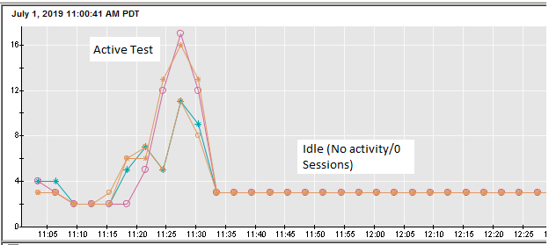

* 1. Heap usage remained the same, GC did not release the heap.

**IHS Plugin configuration changes:** *Load was not being distributed evenly among 4 apps.*

|  |  |
| --- | --- |
|  |  |
| IHS | LoadWeight from 2 to 20 |
| IHS | MaxConnections from Unlimited to 5 |

1. Load balancer had issues with these configurations and have been reverted.
2. Determine if GC is reclaiming heap memory after threads timeout. Wait 10 minutes between each iteration and ensure application servers aren’t restarted between iterations. Take heap dump manually between iterations.
   1. When the heap dump was taken manually the heap usage is reset and goes down.

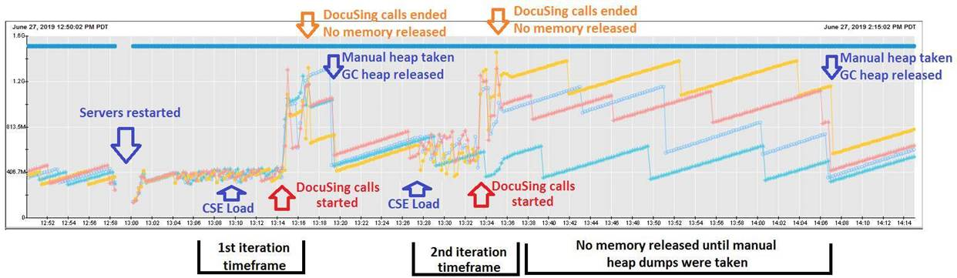

Changes done on EFS Loadbalancer configuration and Tomcat App Server level (CalCloud).

Apache LoadBalancer:

|  |  |
| --- | --- |
| **Old** | mod_jk with ajp protocol |
| **New** | mod_proxy with http protocol |

Tomcat Heap Memory:

|  |  |  |
| --- | --- | --- |
|  | **MinHeap** | **MaxHeap** |
| **Old** | 256mb | 512mb |
| **New** | 1024mb | 2048mb |